Investigation 11B: TORNADOES

1. "Figure 1 is an NCDC graph reporting the U.S. Tornado Averages by Month 1991-2010. It shows that from 1991 to 2010, the most and fewest tornadoes, respectively, occurred in ________."
- May, June
- December, February
- May, December
- June, February

2. "The same figure shows that the seasons with the most and fewest tornadoes, respectively, occurred in ________."
- spring, winter
- spring, fall
- summer, winter
- fall, winter

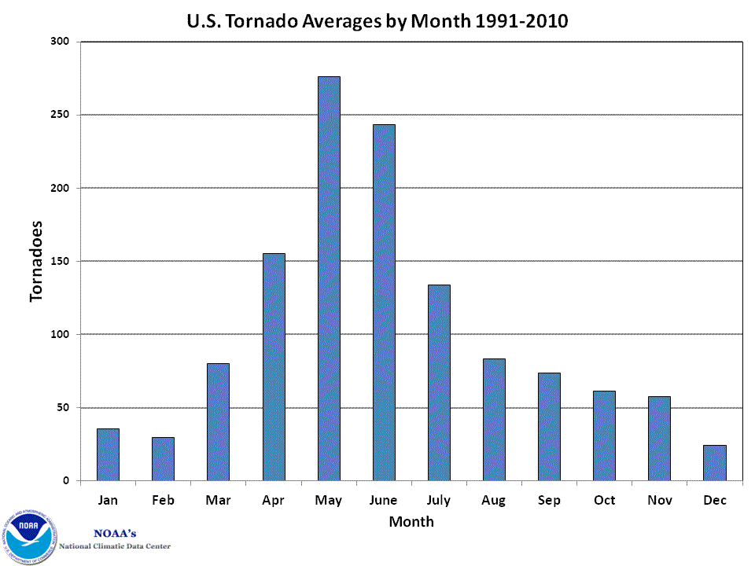

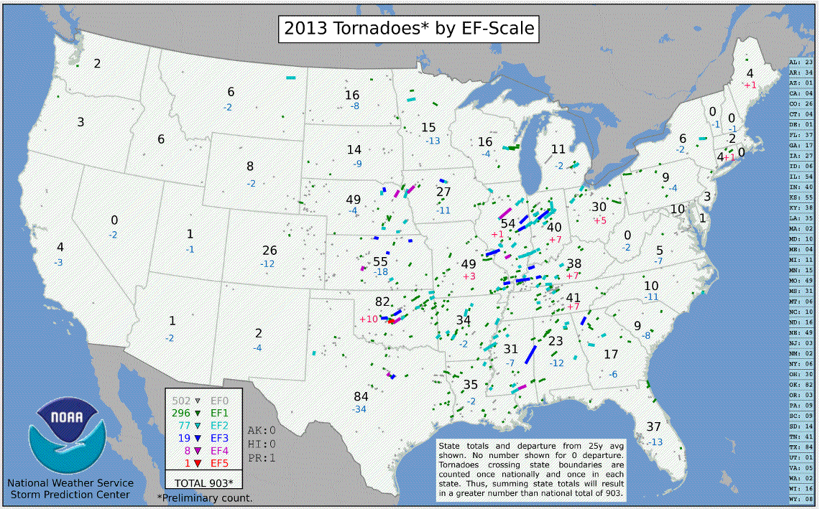

3. "Subsequent to the publication of Figure 2, the latest “final” count for 2013 was altered to 908 tornadoes. For the majority of states, their numbers of 2013 occurrences were ________ their 25-year averages."
- less than
- equal to
- more than

4. "Based on 2013 cases, the “Tornado Alley” region of frequent experiences is located generally along and a state or two to either side of the ________."
- Rocky Mountains
- East Coast
- mid and lower Mississippi River Valley
- West Coast

5. "As noted in the table, 2013 had ________ occurrence(s) of the most devastating tornado, an EF–5 tornado."
- 1
- 2
- 3
- 4

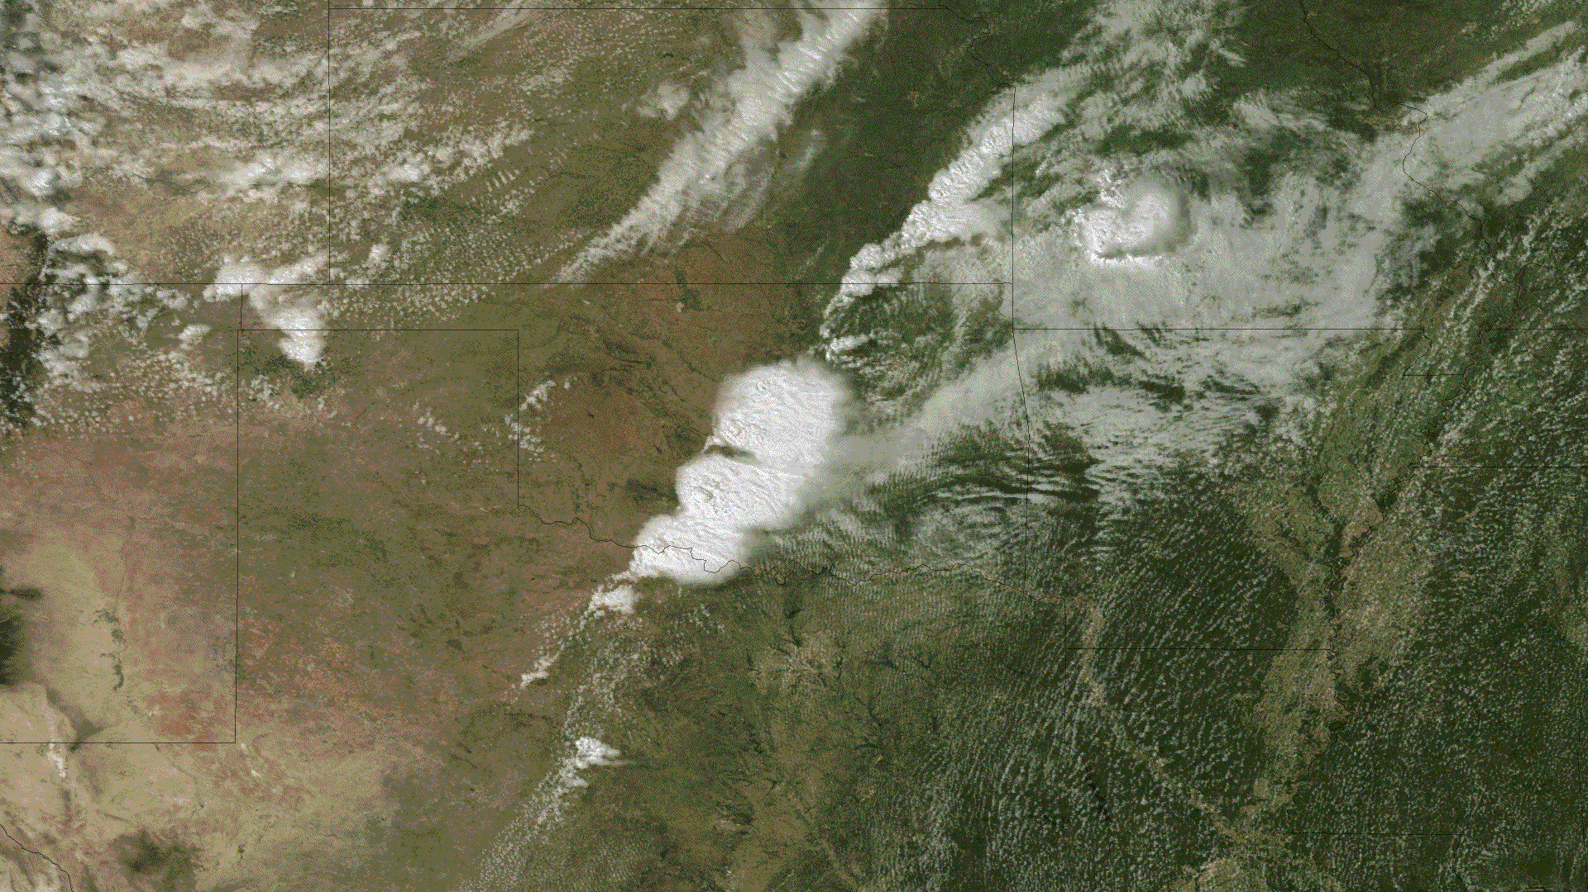

6. "The “lumpy” appearance in the middle of the anvil cloud tops as seen in Figure 3 results from intense convection pushing upward beyond the more flat surroundings. The flat tops typically occur from the thunderstorms reaching the stratosphere, a stable layer. The higher convection in the central lumps is made prominent by shadows produced from low-angle, late-afternoon sunlight from the west. These lumps ________ aptly named “over-shooting tops,” a satellite signature of severe thunderstorms."
- are
- are not
"Figure 4 is a map of central Oklahoma showing the damage path of the tornado that devastated Moore. North is to the top. Oklahoma City is off the top left center of the map area and Moore is labelled to the right center. The NWS Norman Office damage survey map shows the EF-0 damage enclosed within light blue contours, the EF-1 within green, EF-2 yellow, EF-3 orange, EF-4 red and EF-5, the highest, in purple. Table 1 provides EF – scale wind speeds. EF Scale3-Second Gust Speed (mph)
EF 0 65 – 85
EF 1 86 – 110
EF 2 111 – 135
EF 3 136 – 165
EF 4 166 – 200
EF 5 over 200"
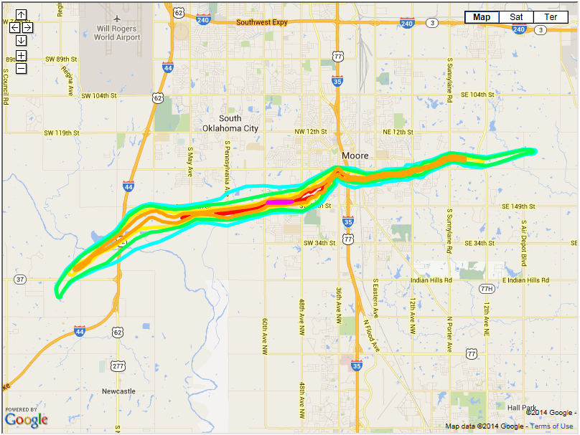

7. "From the elapsed time on the ground and the length of the damage path, the speed of advance of the tornado was approximately ________ mph."
- 10
- 20
- 40
- 60

8. "According to the Figure 4 map shading, the most intense tornado damage classification category (rating) of the Moore tornado was EF– ________."
- 0
- 1
- 2
- 3
- 4
- 5

9. "According to the EF scale, maximum wind speeds in the tornado were in the range of ________ mph."
- 65 - 85
- 86 - 110
- 111 - 135
- 136 - 165
- 166 - 200
- over 200

10. "The track map developed from the damage occurrences indicates that the tornado moved generally toward the ________. This direction was generally aligned with the direction of mid-tropospheric winds at that time."
- southwest
- northwest
- northeast
- southeast

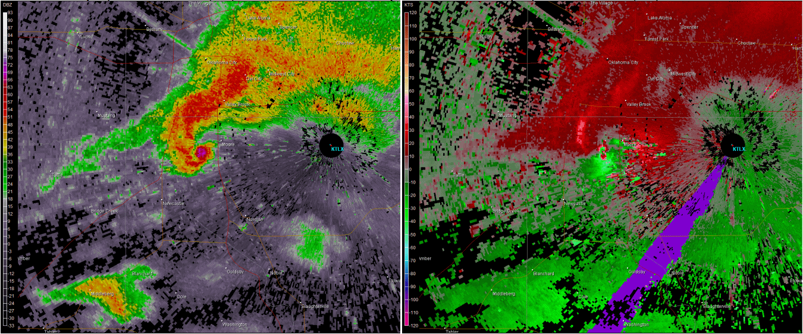

11. "The left reflectivity view shows the intense precipitation in reds associated with the supercell thunderstorm. The ball of purple pixels near the center of the image just southwest of Moore is the most intense reflectivity, resulting from large debris in the air. The red curl-shaped area ending with this ball denotes the “hook echo.” Such an echo ________ alert a meteorologist to the likelihood of tornadic activity at or near that location."
- would
- would not

12. "The radial velocity view on the right in Figure 5 displays the tornadic vortex signature (TVS) appearing near the the center of the view. Note the pattern of bright red and green colors generally separated by an imaginary line extending westward from the radar site, with red to the north and green to the south. Investigation 7B stated that red denotes Doppler velocities away from the radar site and green being toward. Imagine a short arrow drawn on the image away from the radar site across the broad, bright red patch near the center of the view. Also imagine a short arrow toward the radar site across the patch of bright green pixels. Your pair of arrows represents the radial velocities away from and toward the radar’s location. Recalling Investigation 7B, your pattern of arrows suggests a _______ mesoscale circulation as seen from above.
- clockwise
- counterclockwise

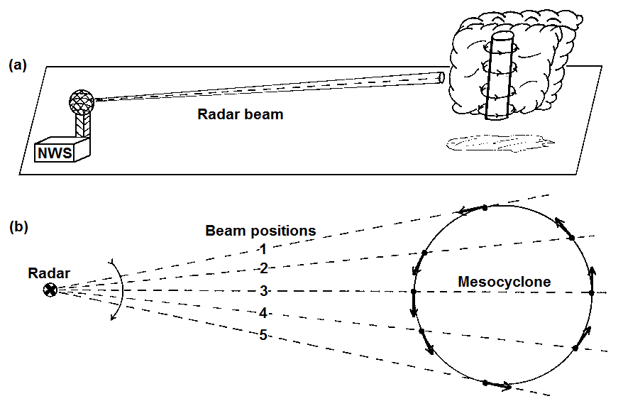

Applications

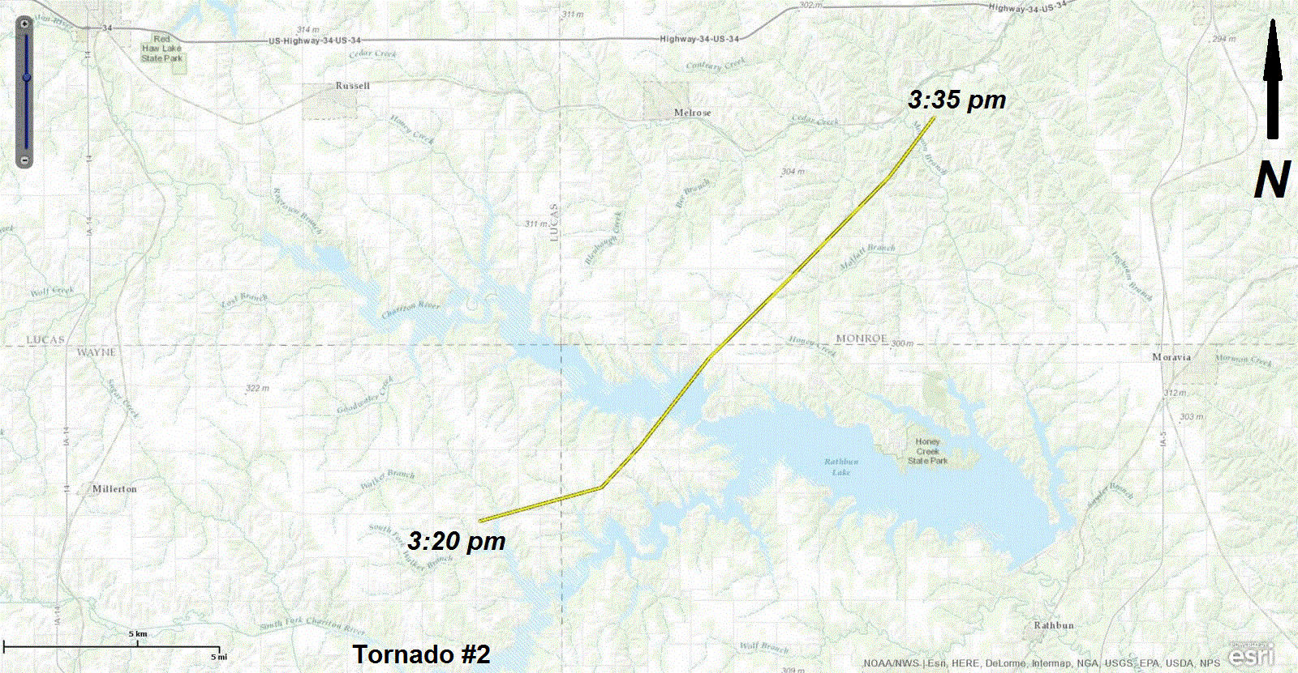

"Tornado #2 (Wayne, Appanoose, and Monroe Counties)
Date Nov. 11, 2015
Time (Local): 3:20 pm – 3:35 pm
EF Rating: EF – 2
Path Length: 14.5 miles
Max. Width: 300 yards"

13. "From the elapsed time on the ground and the length of the damage path, the speed of advance of Tornado #2 was approximately ________ mph."
- 24
- 35
- 41
- 58

14. "According to the listing, the most intense tornado damage classification category (rating) of Tornado #2 was EF- ________."
- 0
- 1
- 2
- 3
- 4

15. "According to the EF scale in Table 1, maximum wind speeds in Tornado #2 were in the range of ________ mph."
- 65 - 85
- 86 - 110
- 111 - 135
- 136 - 165
- 166 - 200
- over 200

16. "According to the track map, the tornado moved generally toward the ________. This direction was generally aligned with the direction of mid-tropospheric winds at that time."
- southwest
- northwest
- northeast
- southeast

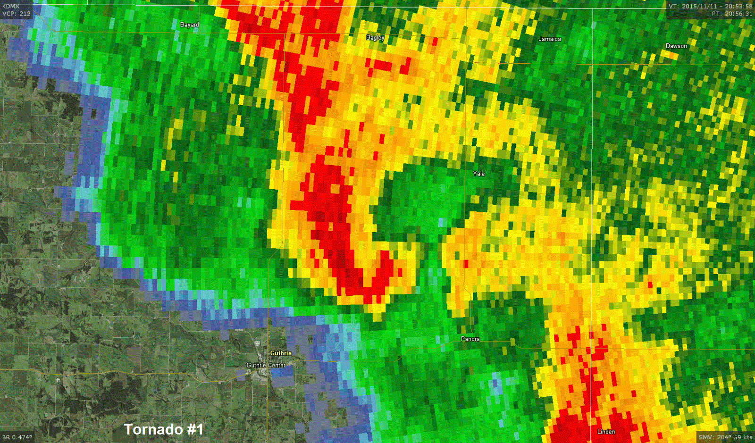

17. "The reflectivity view shows the intense precipitation in reds associated with the supercell thunderstorm. The dark red pixels in the curved arc slightly left of center identify the most intense reflectivity, often resulting from large raindrops, hail, or debris in the air. This red curl area denotes the “hook echo.” A hook-shaped echo ________ alert a meteorologist to the likelihood of wind-driven circulation and tornadic activity at or near that location."
- would
- would not

18. "The shadings of the reflectivity intensities in the view show that there ________ multiple intense thunderstorm cells occurring at this time."
- were
- were not

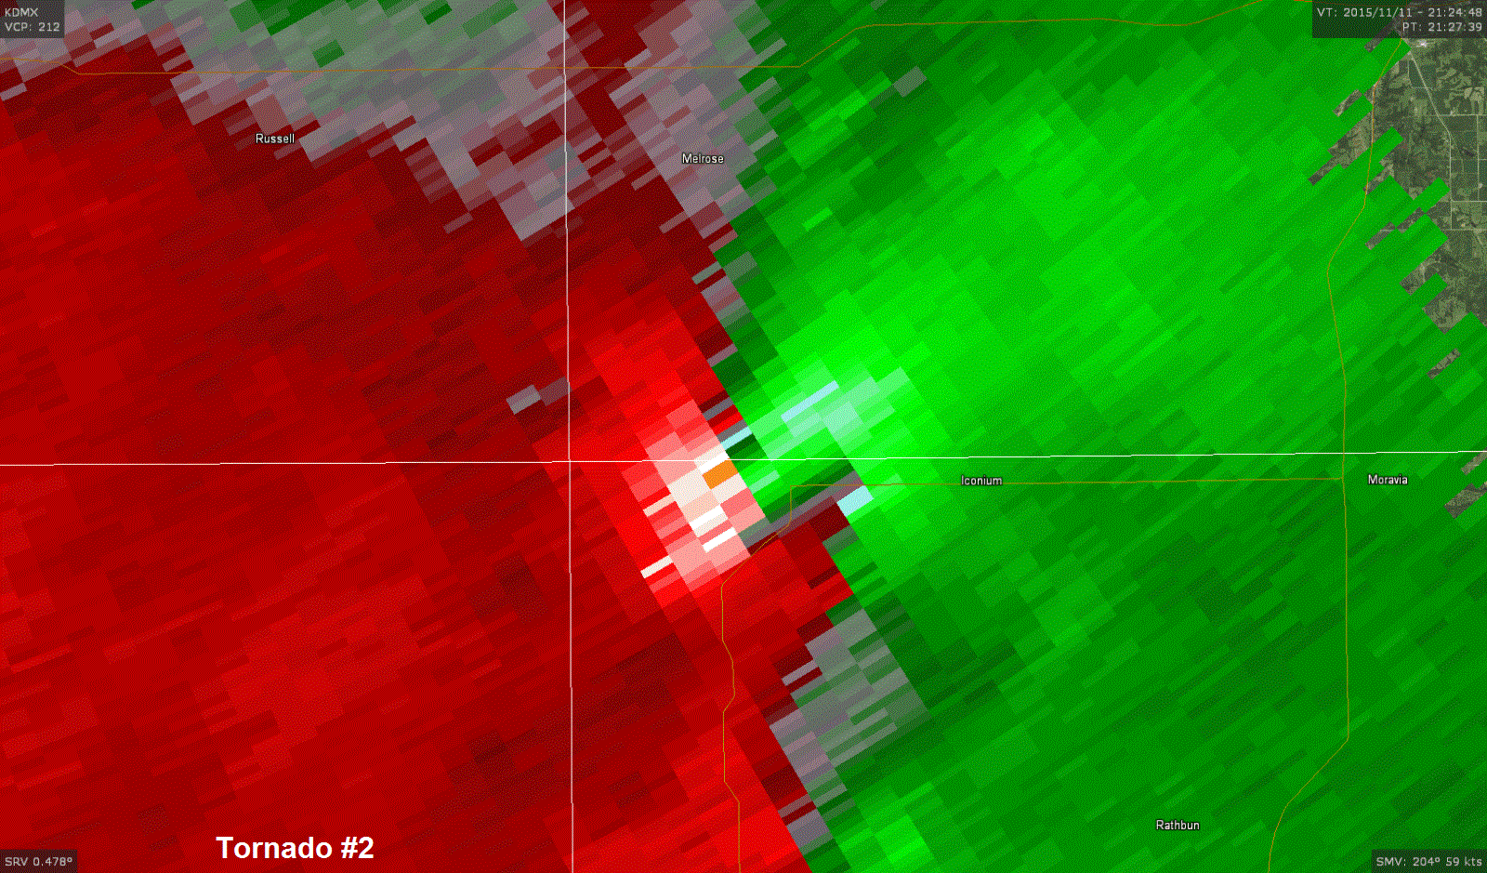

19. "The radial velocity view displays the tornadic vortex signature (TVS) of bright pink (almost white) and bright green colors immediately adjacent to each other near center in the view. Recall from Investigation 7B that red shadings denote Doppler velocities away from the radar site and green being toward. Draw a short arrow away from the radar site (top left corner of the map) across the bright pink patch of the pixels. Also draw a short arrow toward the radar site across the adjacent bright green pixels. Your pair of arrows located to the right of the intersecting lines represents the radial velocities away from and toward the radar’s location of the several mile wide mesocyclone. Recalling Investigation 7B, your pattern of arrows suggests a circulation that is ________ as seen from above."
- clockwise
- counterclockwise

